Data Technician

Name:
Course Date:
Table of contents
Day 1: Task 1 3
Day 1: Task 2 3
Day 1: Task 3 4
Day 2: Task 1 5
Day 3: Task 1 9
Day 3: Task 2 10
Day 3: Task 3 11
Day 4: Task 1 12
Day 4: Task 2 13
1. Scenario Background 13
2. Data Laws and Regulations 14
3. Azure Service Recommendations 14
4. Data Types and Data Modelling 14
5. Data Storage Formats and Structures in Azure 14
6. Additional Considerations 15
Submission Guidelines: 15
Course Notes 17
Additional Information 17

Day 1: Task 1

Please research and complete the below questions relating to key concepts of cloud.

Be prepared to discuss the below in the group following this task.

What can cloud computing do for us in the real-world? | Cloud computing, technology that enables us to access services e.g. email, file storage and software without the need to install locally. It simplifies real-time collaboration and saves time, money and resources that businesses would otherwise invest in localised computer services. Moreover, it makes technology more accessible and easy to manage.
How can it benefit a business? | It benefits a business, enabling them to avoid large upfront hardware costs and maintenance fees associated with physical servers. The business would only pay for resources they use, with the ability to scale resources dynamically. This is a great for businesses who experience demand fluctuations, optimising resource usage without overextending money. A business would also benefit from enhanced security including encryption and automatic updates. Finally, cloud computing allows for real-time collaboration, enhancing productivity across departments.
What’s the alternative to cloud computing? | Local computing
What cloud providers can we use, what are their features and functions? | - Alibaba Cloud (Approx. 6%)- Strong focus on the Asian market with a range of cloud services including IaaS and PaaS.- Comprehensive security features and compliance with local regulations. Offers big data processing and AI services tailored for enterprises.  - Sales force-  - Leader in Software-as-a-Service (SaaS) and Platform-as-a-Service (PaaS) for customer relationship management.  - Unified platform with a focus on customer insights through AI capabilities like Einstein.

Day 1: Task 2

Please research the below cloud offerings, explain what they are and examples of use cases.

Cloud Offerings | Explain what it is | When / how might you use this service in the real-world?
IaaS (Infrastructure as a service) | - A cloud computing model that provides on-demand servers, storage, and networking without the need for physical hardware. | - You might use this service in the real world to set up virtual servers to host applications for app development, game fun or general business operations like project management, data analysis, or collaboration tools.  - Through Iaas, instead of people needing to download word processors or spreadsheets on their devices, they can access it on the web through the virtual servers.  - For instance, if one was developing an app, they would build their mobile application on these virtual services.
PaaS (Platform as a service) | PaaS is a cloud computing model that provides developers with a platform to build, deploy, and manage applications. | This service may be used when a company wants to create an online store. They would use PaaS like Shopify to build the website quickly without worrying about servers and host the e-commerce site directly on the platform, making it accessible to users. Moreover, when using Paas, much of the application management is handled for you by the provider.
SaaS (Software as a service) | Software as a Service (SaaS) is a cloud-based software delivery model where applications are hosted by a service provider and made accessible over the internet. Instead of installing and maintaining software on individual devices, users can simply log in to access the applications through a web browser. | This service is often used when a company wants to collaborate using tools like Google Docs and Google Sheets, allowing teams to work together without needing to install software or manage file sharing via email.  SaaS applications are available online via the web, providing quick access from any device with internet connectivity. Collaboration is made easy through built-in sharing features, enabling multiple users to edit and view documents simultaneously in real-time.

Day 1: Task 3

Please research the below terms and explain what they are, when they would be appropriate and a real-world example of where it could be implemented (i.e. what type of organisation).

Public Cloud
Private Cloud
Hybrid Cloud
Community Cloud

Day 2: Task 1

Describe, with examples, the three major areas that the Computer Misuse Act deals with.

Area | Description | Example

The computer misuse act 1990 is an act where an individual can be criminalised because of computer related offense. Describe three extra powers that the Police and Justice Act 2006 (Computer Misuse) has added.

Description

Look at the below website to answer the questions:
https://www.gov.uk/personal-data-my-employer-can-keep-about-me

Write down three items of data which a company can store about an employee.

Give three more examples of data that an employer can only store if they first get the employee’s permission.

Conduct further research to answer the below questions.

Question | Answer
Provide one example of: Copyright infringement
Provide one example of: Plagiarism

What are two consequences of copyright infringement and software piracy?
Give three possible consequences for individuals when using pirated software

Listed below are some laws which we have covered today:

1. Computer Misuse Act 1990
2. Police and Justice Act 2006 (Computer Misuse)
3. Copyright, Designs and Patents Act 1988
4. Copyright (Computer Programs) Regulations 1992
5. The Health and Safety (Display Screen Equipment) Regulations 1992
6. Data Protection Act 2018
7. Consumer Rights Act 2015

- Insert a number in the first column of each row to match each of the statements with one of the above Acts.

- One of statements is incorrect and not illegal. For this statement, write ‘Not illegal’.

Act number | Clause
 | With some exceptions, it is illegal to use unlicensed software
 | Any product, digital or otherwise, must be fit for the purpose it is supplied for
 | Unauthorised modification of computer material is illegal
 | It is illegal to create or use a hacking tool for penetration testing
 | Personal data may only be used for specified, explicit purposes
 | Employers must provide their computer users with adequate health and safety training for any workstation they work at
 | It is illegal to distribute hacking tools for criminal purposes
 | It is illegal to distribute an illicit recording
 | Personal data may not be kept longer than necessary
 | Gaining unauthorised access to a computer system is illegal
 | Employers must ensure that employees take regular and adequate breaks from looking at their screens
 | It is illegal to prevent or hinder access (e.g. by a denial-of-service attack) to any program or data held in any computer
 | Personal data must be accurate and where necessary kept up to date

Day 3: Task 1

Please complete the below lab (3) ‘Explore relational data in Azure’ and paste evidence of the completed lab in the box provided.



Completed lab | 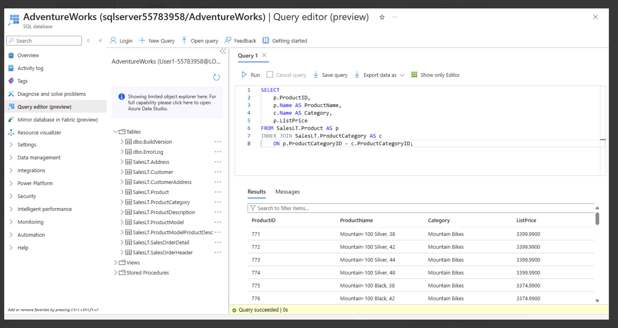

Day 3: Task 2

Please complete the below lab (4) ‘Explore non-relational data in Azure’ and paste evidence of the completed lab in the box provided.



Completed lab | 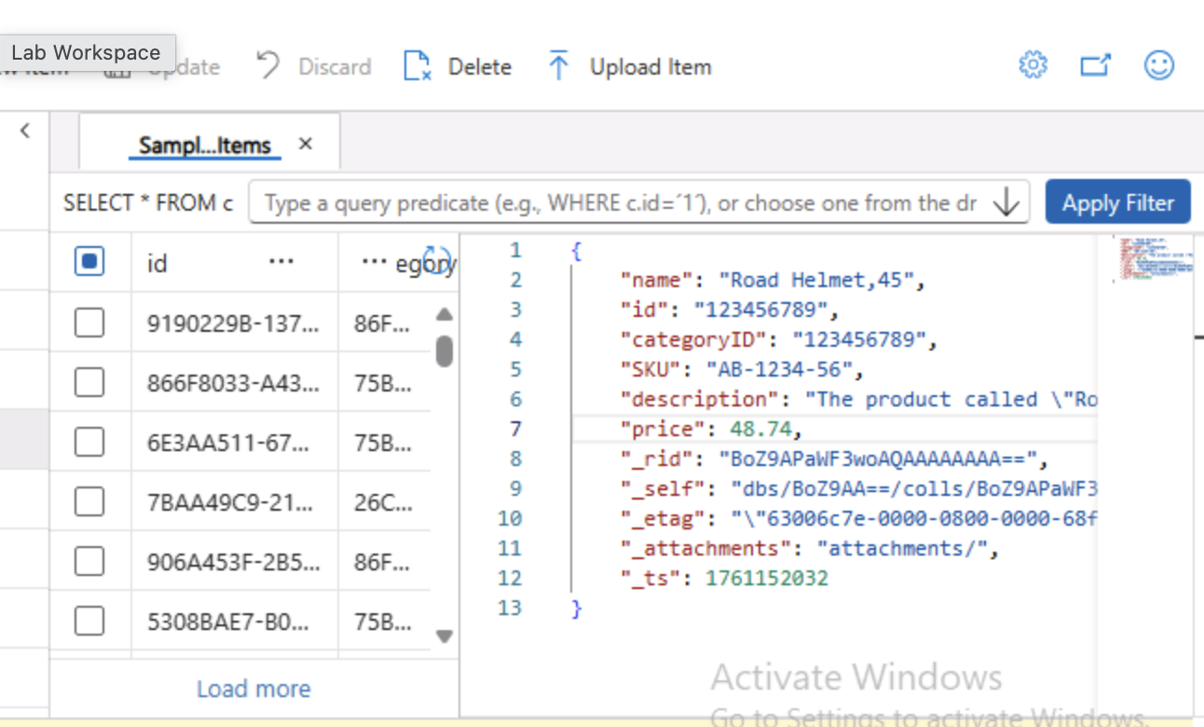  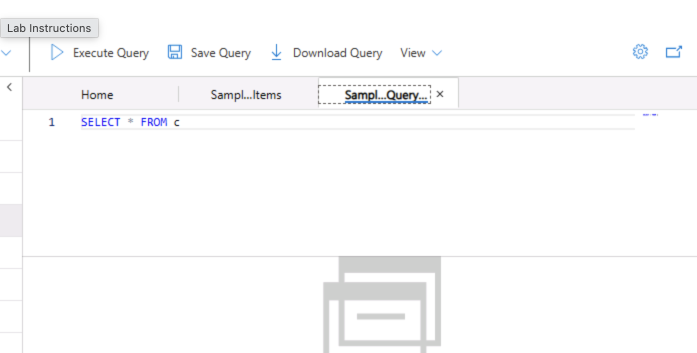  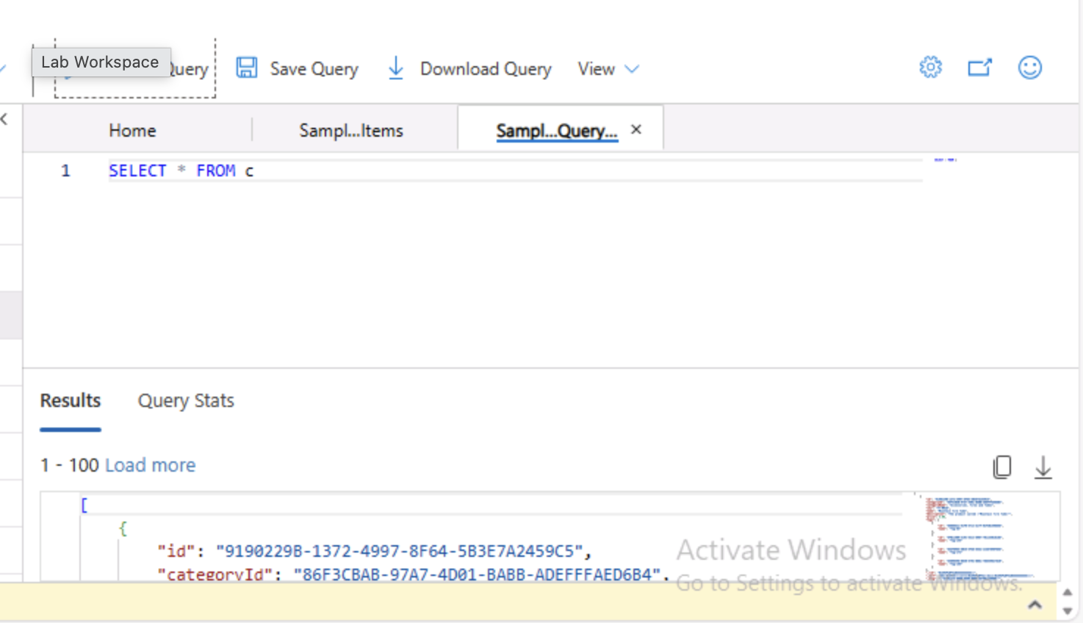

Day 3: Task 3

Please complete the below lab (5) ‘Explore data analytics in Azure’ and paste evidence of the completed lab in the box provided.

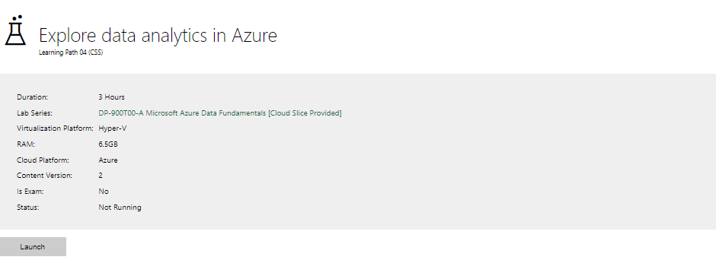

Completed lab | 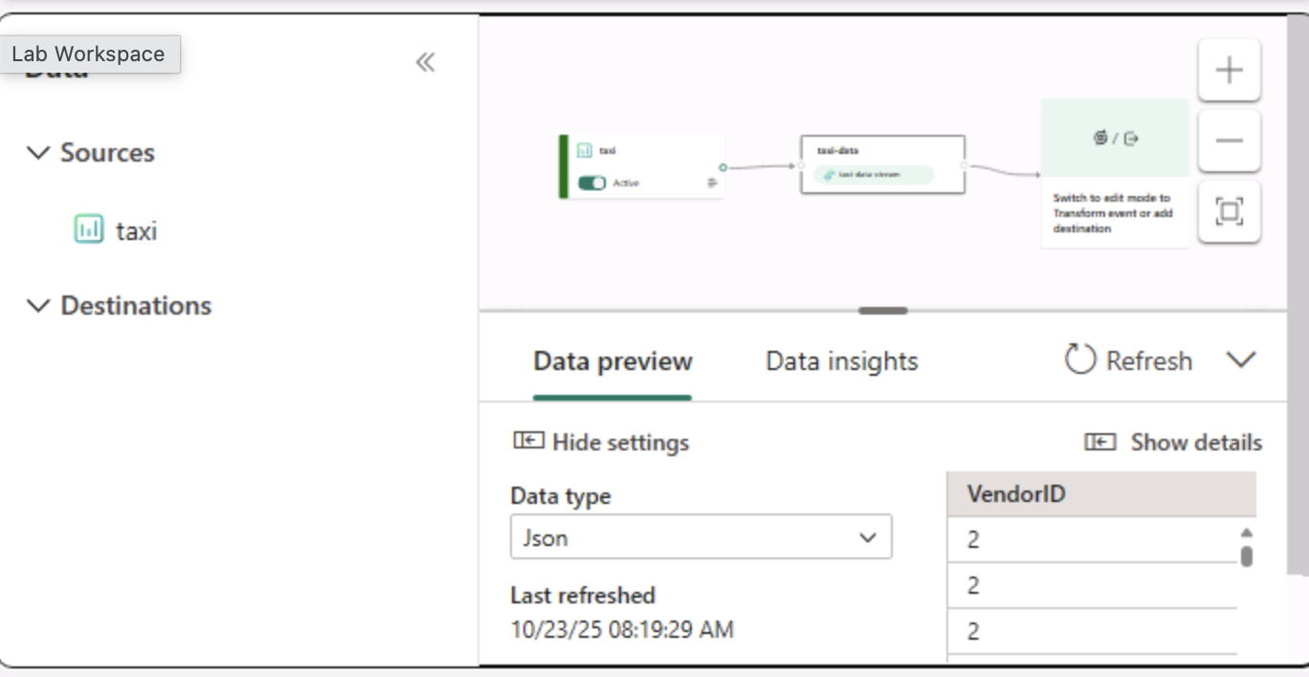  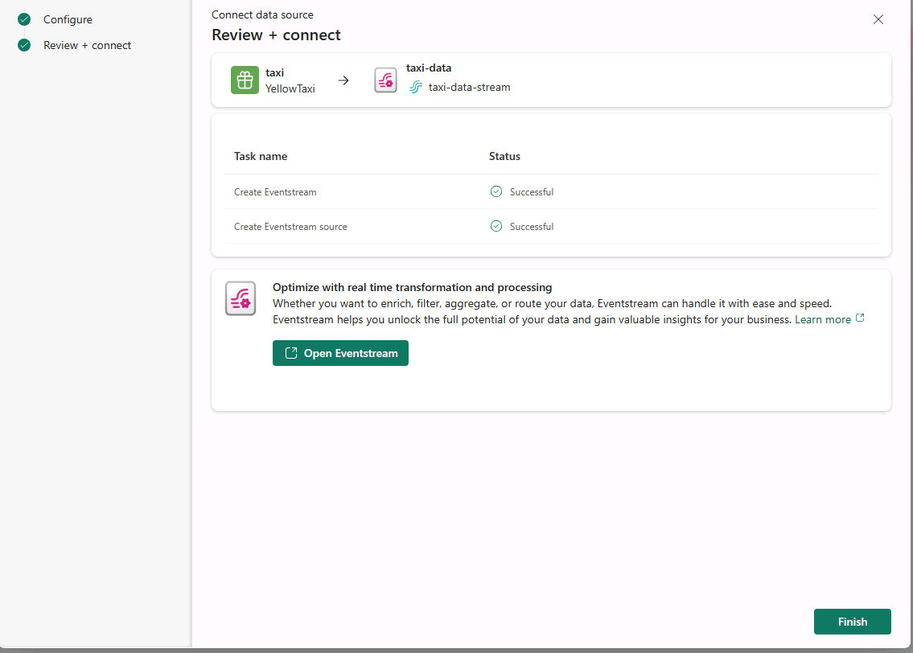  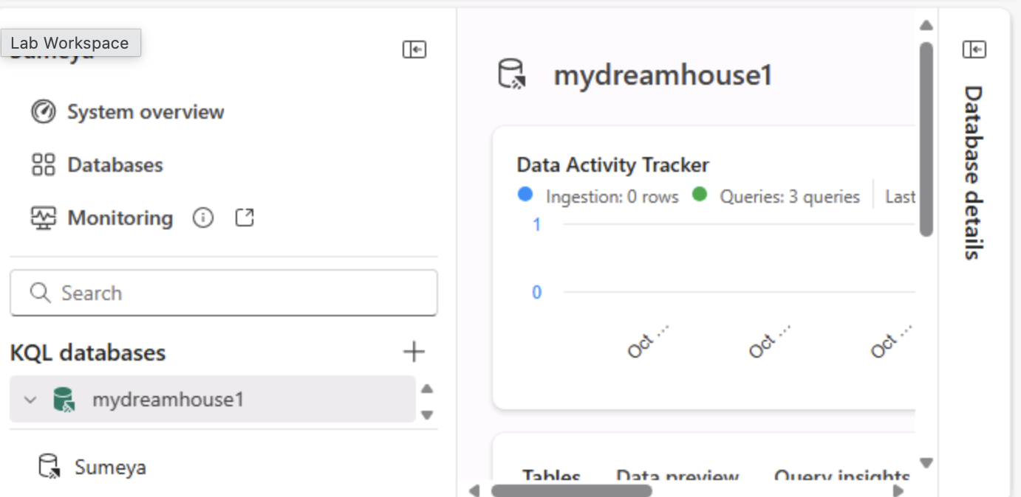  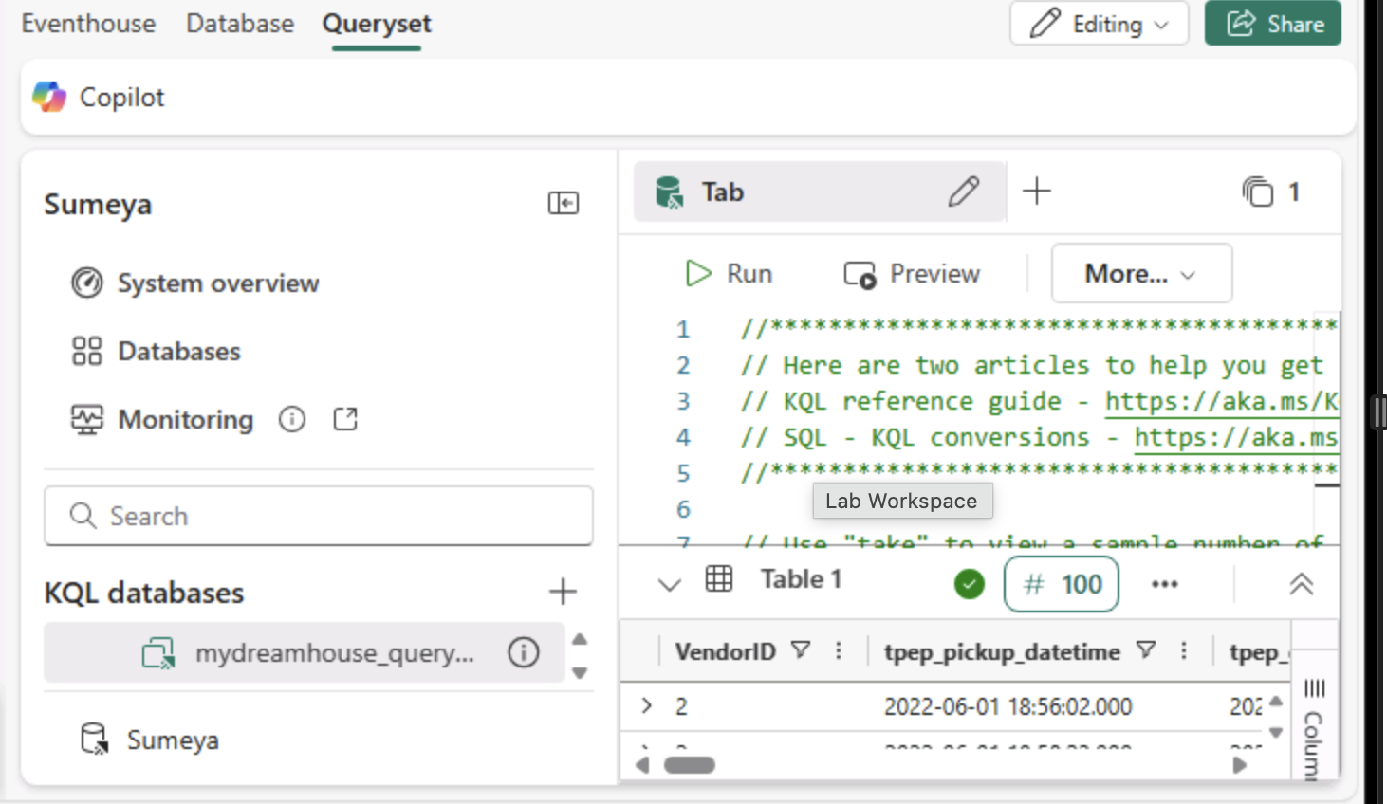  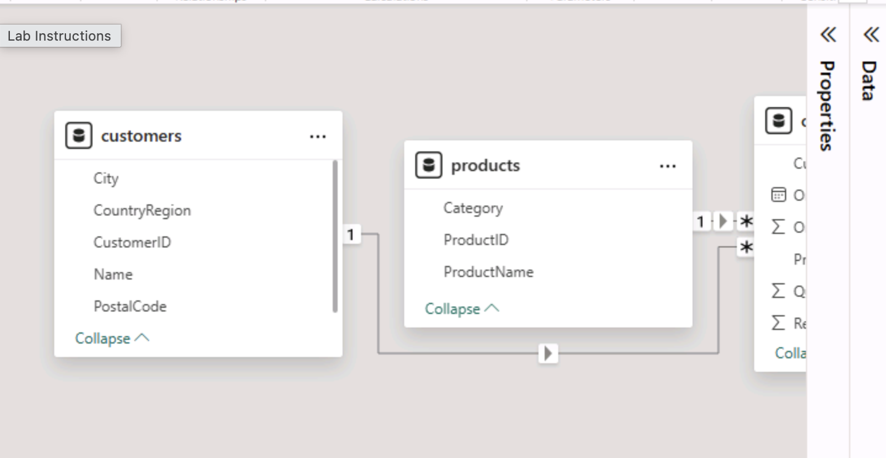  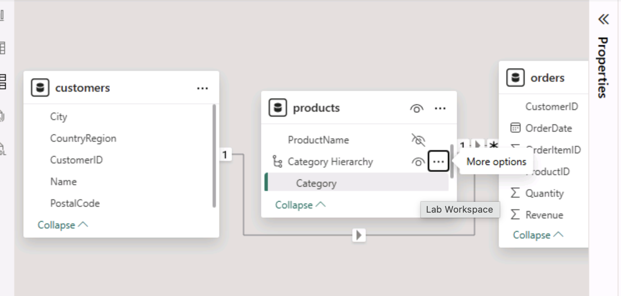  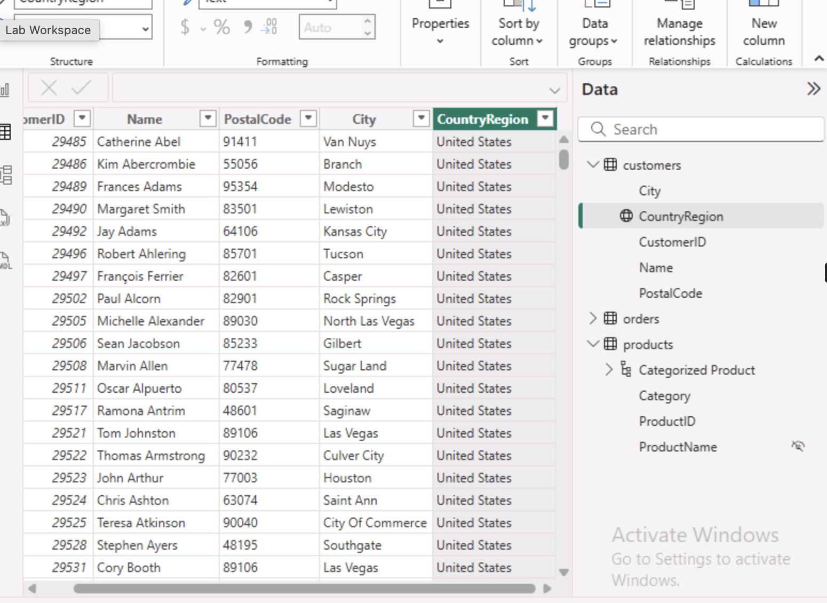  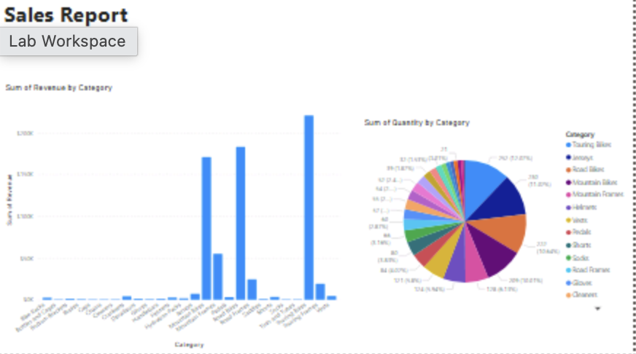

Day 4: Task 1

In your teams, complete the Azure DP-900 practice exam and paste your result below – this is open book and please research and discuss your answers as a team.


Result

Day 4: Task 2

1. Scenario Background
"Paws & Whiskers" is a growing pet shop that aims to improve its business by analysing sales, customer information, and inventory data. Currently, the data is collected manually or stored in spreadsheets. Management is interested in transitioning to Microsoft Azure to streamline data storage, analysis, and reporting, enabling them to make data-driven decisions.

2. Data Laws and Regulations
Identify and explain the data laws and regulations relevant to handling customer data within the proposal. Ensure you cover the following points:
- GDPR Compliance: Highlight the importance of adhering to the General Data Protection Regulation (GDPR), particularly as it relates to storing and processing customer information.
- Data Protection Act (DPA) 2018: Outline how the DPA 2018 may affect the way "Paws & Whiskers" collects and stores data, ensuring compliance with UK laws on data privacy.
- Other Industry Standards: Research any additional data protection standards or regulations that may apply to pet shop data, particularly if they involve sensitive or payment information.

3. Azure Service Recommendations
Recommend Microsoft Azure services that would suit the company’s data analysis needs and explain why these services are suitable. Your recommendations should include:
- Data Storage: Identify suitable storage options, such as Azure Blob Storage or Azure SQL Database, and discuss the benefits of each for storing large datasets, including inventory, sales transactions, and customer details.
- Data Analysis Tools: Recommend tools such as Azure Machine Learning for customer behaviour analysis or Azure Synapse Analytics for analysing sales trends.
- Data Integration and Automation: Explain how services like Azure Data Factory could automate data collection and integration processes, improving efficiency.

4. Data Types and Data Modelling
Define the types of data "Paws & Whiskers" will need to work with and describe your approach to data modelling:
- Data Categories: Identify key data types, such as customer demographics, transaction history, pet inventory, and product categories.
- Data Modelling Approach: Outline how you would structure this data using a relational model or a data warehouse approach, considering factors like tables, entities, relationships, and primary keys.

5. Data Storage Formats and Structures in Azure
Discuss how you would store data within Azure and the formats you would recommend:
- Data Formats: Specify recommended formats (e.g., CSV for raw data imports, JSON for structured data, Parquet for analytics) and explain why these formats are suitable for specific data types.
- Data Security and Encryption: Include recommendations for securing data using Azure’s built-in encryption features and access controls to ensure compliance with data privacy regulations.

6. Additional Considerations
Provide any other considerations that might enhance data handling and efficiency in Azure, such as:
- Backup and Disaster Recovery: Outline a backup plan using Azure Backup or Azure Site Recovery to safeguard against data loss.
- Data Visualisation: Discuss potential use of Power BI within Azure for creating dashboards that provide management with real-time insights into sales and customer trends.
- Future Scalability: Comment on how Azure services can scale as the business grows, accommodating larger datasets and more complex analyses.

Submission Guidelines:
- Structure: Ensure your report is well-organised, with sections for each task (e.g., Data Laws, Azure Services, Data Types, etc.).
- Formatting: Include headings, bullet points where appropriate, and any visuals or diagrams that support your explanations.
- References: Cite any resources or regulations referenced in the report.
- Length: Aim for 1500-2000 words.

Course Notes

It is recommended to take notes from the course, use the space below to do so, or use the revision guide shared with the class:

Additional Information

We have included a range of additional links to further resources and information that you may find useful, these can be found within your revision guide.

END OF WORKBOOK

Please check through your work thoroughly before submitting and update the table of contents if required.

Please send your completed work booklet to your trainer.

